[](http://www.mdmlg.org/)

**METROPOLITAN DETROIT MEDICAL LIBRARY GROUP (MDMLG)**

ARCHIVIST

Annual Report

2011 - 2012

**OBJECTIVES:**

1. Make timely deposits of materials as received from the membership to the Reuther Library of Labor and Urban Affairs..
2. Seek out archival material which is lacking or will enhance the collection
3. Keep the membership aware of the material at the Reuther Library and its availability. To publish/post information about the archives to membership
4. Publicize the material in the Walter P. Reuther Library to appropriate non-MDMLG groups and individuals;
5. Maintain contact with the archivist responsible for the MDMLG materials at the Reuther Library;
6. To arrange for at least one visit during the year. and to investigate developing current finding aids for the collection

**ACCOMPLISHMENTS:**

1. Gathered committee and officer documents.

.

__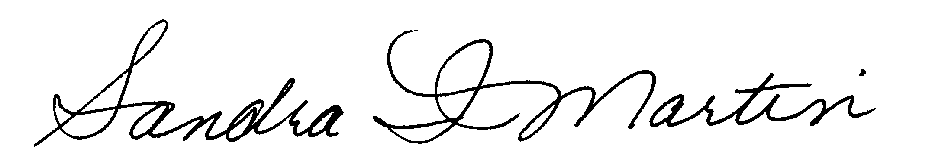_______ June 5, 2013

Sandra I. Martin, ARCHIVIST DATE